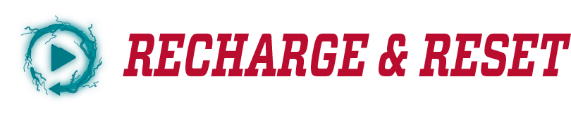

**University of New Mexico**

**Academic Program Assessment**

In Academic Year 25-26, the University of New Mexico will temporarily *pause assessment* *reporting* to enable all academic programs to *recharge and reset* *their assessment*. UNM Albuquerque and branch campuses reached a 65.7% assessment submission rate in AY 23-24, the highest submission rate in four years. That's great progress. At the same time, Office of Assessment and Academic Program Review (OAAPR) analysis of academic program assessment indicates that the majority of programs are assessing improvement that has long since been achieved. Overall, UNM assessment can be improved through the introduction of new measures, practices, and goals. The process for achieving this is described below.

**5-year assessment plan**

In AY 25-26, a year's pause in reporting will enable academic programs to recharge and refresh, using the Assessment Reflection (see below). **No assessment reports will be due during that time.** The reflection forms the basis for transitioning to a new Assessment Plan Template [link] and an Action Plan [link] for implementing your new assessment. The reflection, template, and action plan will support you in developing a refreshed approach to assessment. Your updated assessment plan should be submitted to your College Assessment Review Committee (CARC) Chair in Fall 2026 (by the due date set by your college/school/branch). All assessment plans will be reviewed for success indicators, alignment between outcomes and measures, and specific methods of analysis.

In AY 26-27, the University of New Mexico will restart collection of evidence for academic program assessment based on your new assessment plan. From AY 27-28 to AY 31-32, all academic programs will follow the *same* five-year "plan cycle" or timeline for evidence collection and reporting. This timeline will align with the cycle of the Higher Learning Commission (HLC) assurance of UNM accreditation.

**Assessment reflection**

The OAAPR has developed an assessment reflection for each degree program to complete in lieu of an assessment report in AY 26-27 located on the [assessment website](https://assessment.unm.edu/assets/documents/reflection-assessment-reset.docx). The assessment reflection will be submitted along with an updated assessment plan in Fall 2026. The reflection component encourages programs to provide a contextual understanding of their previous assessment practices and support mechanisms. Program reflections will help inform the future direction of institutional assessment practices in support of the upcoming HLC assurance argument. The reflections will be turned into your College Assessment Review Committee (CARC) Chair in the fall of 2026. Please adhere to your college/school deadlines for the exact due date.

Timeline: FALL SPRING

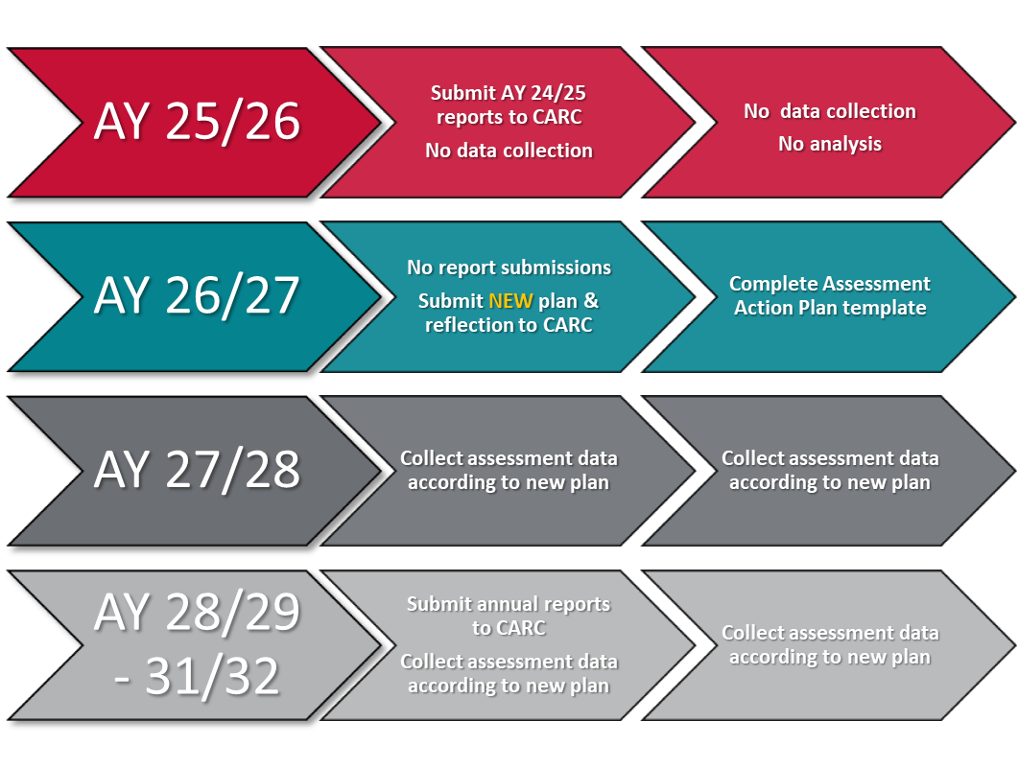

**Assessment Reports: AY 27/28-31/32**

UNM’s academic program assessment cycle allows units to collect, analyze, and report data/results pertaining to their degree program outcomes for a five-year period. During each year of this cycle, each academic unit will submit an assessment report to their CARC/CBCARC for an internal review. Please check with your assessment committee chair for your AY 27-28 assessment report due date. Once this review is completed, the annual assessment report will be submitted to the OAAPR via Form Stack (formerly the UNM repository system) by the Assessment Committee Chair. The OAAPR will inventory and analyze the annual program reports to create an institution-wide report. In addition, the OAAPR will produce customized reports for each college and school to provide specific assessment results for your entity. The OAAPR will also provide feedback to a sample of participating programs each year on a rotating basis so that all programs are included in a feedback cycle within the five-year span. This feedback and customized report will be given to the assessment committee chair and college/school leadership to be shared with Program Chairs and faculty.

**Assessment planning support**

Please utilize your reflection and the following assessment resources to update and/or create a new assessment plan:

1. Assessment plans are for an entire degree program. Map outcomes to your entire set of academic courses to align representation and understanding of which student populations and which content areas are robust. For more information, see the Curriculum Mapping workshop on our [workshop’s page](https://assessment.unm.edu/events/index.html).
2. Please refer to the best practices guidelines on our website for suggestions toward streamlining assessment, creating overarching goals for all degree programs, and customizing outcomes for each degree level: <https://assessment.unm.edu/academic-assessment/index.html>
3. Contact your college/school assessment committee chair for feedback, consultation, and/or additional assessment ideas.
4. Contact the OAAPR for goals/outcomes, data collection, and data analysis support: [assess@unm.edu](mailto:assess@unm.edu)

**College/School Next Steps**

* Due Fall 2026: **Complete assessment reflection** utilizing the couple of assessment cycles, reports and most current assessment plan
* Due Fall 2026: **Complete new assessment plan** utilizing:
  + your assessment and curriculum committees
  + unit vision & mission
  + learning outcomes scale up and down to include all levels of degrees
  + accreditation reports
  + APRs, strategic plan
  + industry and discipline standards
  + shared student learning outcomes with other entities such as DEI, community engagement, or interdisciplinary programs

**Frequently Asked Questions**

1. **What if I just completed a new assessment plan during the last assessment cycle?**

If you created a new assessment plan recently, please copy that plan information into the new assessment plan template to be submitted.

1. **Does this Recharge & Reset year include a pause on General Education assessment?**

The Recharge & Reset year is solely a pause on academic program assessment. The general education assessment cycle continues as normal.

1. **Is the new UNM branch assessment model included in the Recharge & Reset?**

Any branch participating in the new branch assessment model will continue their assessment cycle as normal since it is merged with general education assessment. Any branch campus participating in the traditional UNM academic program assessment model will pause on their academic assessment cycle in the Recharge & Reset year.

If you have not been part of the annual institutional assessment cycle and need to learn about UNM requirements, need a refresher, or more information on Recharge & Reset, please contact us @ [assess@unm.edu](mailto:assess@unm.edu).

**UNM Assessment Reflection**

This reflection acts as a guide to think about your previous assessment practices and support mechanisms as well as your future monitoring of student success. Program reflections will also help inform institutional assessment practices in support of the upcoming HLC assurance argument. Please turn your reflection into your College Assessment Review Committee (CARC) Chair in the fall of 2026.

1. Describe how your assessment process (es) has been effective for (1) building, (2) implementing, and (3) communicating with students regarding their learning behaviors/outcomes.
2. Over the last few (2-3) assessment cycles, share how have you used the information gained from your assessment to improve student learning.
3. Please describe how your assessment/student learning improvement methodologies reflect good practice, as well as how your college/school/institution supports these assessment practices. These can be examples of curricular and assessment committee action, current policies and procedures, assessment retreat results, collegiate and leadership assessment engagement, campus partnerships and resources that support assessment, how GTAs are involved in the assessment process, and/or your professional development opportunities that support your efforts to monitor student learning improvement.
4. Please provide any areas of your assessment process that can be strengthened (e.g. SLO development, building a specific assessment tool, designating benchmarks, analyzing assessment results, alignment with graduate or undergraduate program in same dept, etc)?