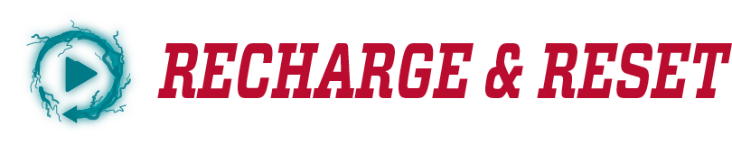

**UNM Academic Assessment Reflection**

This reflection acts as a guide to think about your previous assessment practices and support mechanisms as well as your future monitoring of student success. Program reflections will also help inform institutional assessment practices in support of the upcoming HLC assurance argument. Please turn your reflection into your College Assessment Review Committee (CARC) Chair in the fall of 2026.

1. Describe how your assessment process (es) has been effective for (1) building, (2) implementing, and (3) communicating with students regarding their learning behaviors/outcomes.
2. Over the last few (2-3) assessment cycles, share how have you used the information gained from your assessment to improve student learning.
3. Please describe how your assessment/student learning improvement methodologies reflect good practice, as well as how your college/school/institution supports these assessment practices. These can be examples of curricular and assessment committee action, current policies and procedures, assessment retreat results, collegiate and leadership assessment engagement, campus partnerships and resources that support assessment, how GTAs are involved in the assessment process, and/or your professional development opportunities that support your efforts to monitor student learning improvement.
4. Please provide any areas of your assessment process that can be strengthened (e.g. SLO development, building a specific assessment tool, designating benchmarks, analyzing assessment results, alignment with graduate or undergraduate program in same dept, etc)?